**Interactive Blogging Platform**

**A Minor Project Synopsis Submitted to**



**Rajiv Gandhi Proudyogiki Vishwavidyalaya, Bhopal**

**Towards Partial Fulfillment for the Award of**

**Bachelor of Technology**

**(Computer Science and Engineering)**

**Under the Supervision of Submitted By**

**Prof . Dr. Santosh Varshney Jigyansh Sisodiya (0287CS211111)**

**Krishna Bhawsar Jaydeep Malvya ((0287CS2111090287CS211128))**

**Krishna Gupta (0287CS211129)**



**Department of Computer Science and Engineering**

**Acropolis Institute of Technology & Research, Indore**

**July-Dec 2023**

# 1. Introduction of the Project

Introducing our groundbreaking interactive blogging platform where audience engagement is at the forefront. In addition to providing creators with dynamic multimedia tools, we prioritize fostering meaningful connections through audience interaction. With our intuitive commenting system, readers can seamlessly engage with content, share their thoughts, and contribute to vibrant discussions. Whether it's sparking debates, offering insights, or simply expressing appreciation, our platform empowers audiences to actively participate in the conversation, enriching the overall blogging experience for both creators and readers alike. Join us as we redefine the way communities interact and collaborate within the realm of online content creation.

# 2. Objective

The objective of our interactive blogging platform project is to create a dynamic and engaging online space that fosters meaningful connections and interactions between creators and their audiences. By integrating innovative multimedia tools and a userfriendly commenting system, we aim to empower creators to produce captivating content while providing audiences with the opportunity to actively engage, share insights, and build communities around shared interests. Ultimately, our goal is to revolutionize the traditional blogging experience, enhancing both content creation and consumption in a way that promotes collaboration, dialogue, and connection within the online community.

# 3. Scope

The scope of our interactive blogging platform project encompasses the development and implementation of a comprehensive online platform that facilitates dynamic content creation and audience engagement. This includes the design and development of user-friendly interfaces for creators to compose and publish multimedia-rich blog posts, as well as the integration of interactive features such as embedded videos, polls, quizzes, and live Q&A sessions. Additionally, the project scope involves the implementation of a robust commenting system that allows audiences to share feedback, discuss topics, and interact with both creators and fellow readers. Furthermore, the project encompasses the deployment of scalable infrastructure to support a growing user base and the continuous improvement of platform features based on user feedback and emerging trends in online content creation and engagement.

# 4. Study of Existing System

1. **WordPress**

**Characteristics:**

* + **Open Source:** WordPress is an open-source platform, which means its source code is freely available to the public.
  + **Modularity:** WordPress is built on a modular architecture, allowing users to extend its functionality through themes and plugins.
  + **User-Friendly Interface:** WordPress features an intuitive and user-friendly interface.

**Advantages:**

* + **Ease of Use:** You don't need to have extensive technical knowledge to set up and manage a WordPress website or blog.
  + **Flexibility:** With thousands of themes and plugins available, WordPress offers unparalleled flexibility and customization options.
  + **Large Community and Support:** WordPress has a vast and active community of users, developers, and contributors.

**Disadvantages:**

* + **Maintenance Required:** While WordPress simplifies many aspects of website management, it still requires regular maintenance.
  + **Performance Concerns:** A heavily customized WordPress site with numerous plugins can sometimes suffer from performance issues, such as slow loading times.
  + **Security Risks:** Because of its popularity, WordPress can be a target for hackers and malicious attacks.

Reference Link: [WordPress.org](https://wordpress.org/)

1. **Blogger**

**Characteristics:**

* + **Owned by Google:** Blogger is a free blogging platform owned and operated by Google.
  + **Free Hosting:** Blogger offers free hosting for blogs, eliminating the need for users to purchase separate hosting services.
  + **Integration with Google Services:** Blogger seamlessly integrates with other Google services, such as AdSense for monetization, Analytics for tracking website traffic etc.

**Advantages:**

* + **Ease of Use:** Blogger is known for its simplicity and user-friendly interface, making it easy for beginners to start a blog without any technical knowledge.
  + **Free Hosting:** Blogger is a free platform provided by Google, which means you don't need to worry about hosting costs.
  + **Reliability:** As a service provided by Google, Blogger offers reliable hosting and uptime.

**Disadvantages:**

* + **Limited Features:** Compared to other blogging platforms like WordPress, Blogger has fewer features and customization options.
  + **Limited Design Options:** While Blogger provides a selection of templates for customization may find it challenging to create a unique and visually appealing blog design.
  + **Ownership and Control:** When you use Blogger, you don't have full ownership and control over your blog. Since it's hosted on Google's servers.

Reference Link: [Blogger](https://www.blogger.com/)

1. **Medium:**

**Characteristics:**

* + **User-Friendly Interface:** Medium offers a clean and minimalist writing interface that prioritizes readability and simplicity.
  + **Built-in Audience:** Medium has a large and diverse user base, consisting of readers interested in a wide range of topics.
  + **Curated Content:** Medium employs algorithms to curate and recommend content based on users' interests and reading history.

**Advantages:**

* + **Ease of Use:** The simple writing interface and automatic formatting make it easy for writers to focus on their writing.
  + **Built-in Audience:** With its large and diverse user base, Medium offers writers access to a built-in audience of readers interested in a wide range of topics.
  + **Discoverability:** Medium's algorithms curate and recommend content based on users' interests and reading history, making it easier for readers to discover new and relevant content.

**Disadvantages:**

* + **Limited Control:** Writers have limited control over the design and customization of their publications on Medium.
  + **Competition:** With a large and diverse community of writers, Medium can be highly competitive, making it difficult for new.
  + **Limited Branding:** Medium's focus on a consistent reading experience means that writers have limited opportunities to brand their content.

Reference Link: [Medium](https://medium.com/)

# Methodology/Planning of the Project work

The planning and methodology of our interactive blogging platform project involve several key phases to ensure its successful development and implementation:

1. **Requirement Analysis:** This initial phase involves identifying and documenting the project's requirements, including features, functionalities, and user expectations. We conduct thorough market research to understand user needs and preferences, competitor analysis, and technological feasibility assessments.
2. **Design Phase:** In this phase, we create detailed design specifications based on the requirements identified in the previous phase. This includes designing the user interface, database structure, system architecture, and data flow diagrams. We prioritize user experience (UX) design to ensure the platform is intuitive, visually appealing, and user-friendly.
3. **Development:** The development phase involves coding and building the platform according to the design specifications. We follow an iterative development approach, breaking down the project into smaller tasks or sprints, typically using Agile methodologies such as Scrum or Kanban. Continuous integration and testing are integral parts of this phase to ensure code quality, functionality, and compatibility across different devices and browsers.
4. **Testing and Quality Assurance:** Throughout the development process, rigorous testing is conducted to identify and address any bugs, errors, or usability issues. This includes functional testing, user acceptance testing (UAT), performance testing, security testing, and compatibility testing. Quality assurance measures are implemented to ensure the platform meets high standards of reliability, scalability, and security.
5. **Deployment and Launch:** Once development and testing are complete, the platform is prepared for deployment to production servers. We carefully plan and execute the deployment process to minimize downtime and ensure a smooth transition from development to live environment. Post-launch monitoring and support are provided to address any issues or concerns that may arise.
6. **User Feedback and Iteration:** After the platform is live, we actively solicit user feedback and monitor user engagement metrics to gather insights into user behavior and preferences. This feedback loop informs iterative improvements and updates to the platform, ensuring it remains relevant, competitive, and aligned with user needs over time.
7. **Maintenance and Support:** Ongoing maintenance and support are provided to address technical issues, implement new features or enhancements, and ensure the platform's continued functionality and performance. Regular updates, security patches, and backups are performed to safeguard the platform's integrity and mitigate potential risks.

# 6. Features

1. **Multimedia-rich content creation:** Creators can compose blog posts with embedded multimedia elements such as videos, images, and audio to enhance storytelling and engage audiences visually and audibly.
2. **Interactive tools:** The platform offers a variety of interactive tools including polls, quizzes, surveys, and live Q&A sessions that creators can integrate into their posts to encourage audience participation and feedback.
3. **User-friendly commenting system:** Audiences can easily engage with content by leaving comments, sharing insights, and participating in discussions, fostering community interaction and collaboration.
4. **Customizable templates:** Creators have access to customizable templates and layouts to tailor the visual presentation of their blog posts according to their unique branding and content needs.
5. **Social media integration:** Seamless integration with social media platforms enables creators to amplify their reach and engagement by sharing blog posts across various social networks and encouraging audience interaction beyond the platform.
6. **Analytics and insights:** Creators can track the performance of their blog posts through built-in analytics tools, gaining valuable insights into audience engagement, demographics, and content effectiveness.
7. **Community building features:** The platform includes features for building and nurturing communities around shared interests, allowing creators to connect with likeminded individuals and foster meaningful relationships among audience members.
8. **Responsive design:** The platform is designed with responsive layouts and mobilefriendly interfaces, ensuring optimal user experience across a variety of devices and screen sizes.
9. **Content moderation tools:** Moderation tools are provided to help creators manage and monitor user-generated content, ensuring a safe and respectful environment for audience interaction.
10. **Continuous improvement:** The project includes plans for ongoing development and improvement based on user feedback, emerging trends, and advancements in technology, ensuring the platform remains innovative and relevant in the everevolving landscape of online content creation and engagement.

# System architecture

The system architecture for a blogging platform comprises several interconnected components working together to provide a seamless user experience. At the core of the architecture is a Content Management System (CMS), responsible for managing content creation, storage, and retrieval. User interactions occur through the User Interface (UI), where users can create, edit, and publish blog posts.

Authentication and authorization components ensure secure access to the platform, while a database stores user accounts, posts, comments, and metadata. Media files associated with posts are stored in a separate file storage system, and a search engine component provides quick access to relevant content.

A Content Delivery Network (CDN) improves performance by caching and delivering static assets, while analytics and monitoring tools track user behavior and system performance. APIs enable integration with third-party services, and a notification system keeps users informed about relevant activities on the platform.

Together, these components create a robust blogging platform architecture that prioritizes usability, security, scalability, and performance, providing users with an engaging and efficient blogging experience.

* **Entity Relationship diagram**

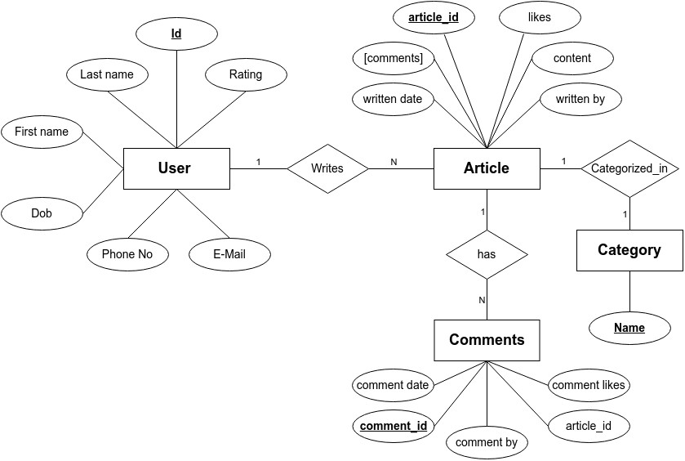

* **Data flow diagram**

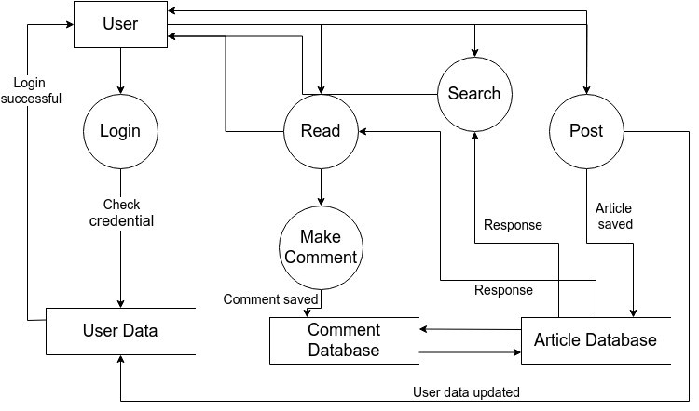

# 8. User Interface (UI)

Describe the user interface design. You can include wireframes or mockups if applicable.

**Homepage:**

* The homepage serves as the gateway to the blogging platform, showcasing featured posts, trending topics, and recent updates.
* It typically includes a navigation bar or menu for easy access to different sections of the platform, such as the user's profile, categories, and search functionality.

**User Profile:**

* The user profile page provides information about the user, including their bio, profile picture, and a list of their published posts.
* Users can edit their profile details, manage their published posts, and view statistics such as post views, likes, and comments.

**Search and Navigation:**

* Search functionality allows users to find specific posts or topics of interest quickly.
* Navigation elements like breadcrumbs, sidebars, or dropdown menus help users explore different sections of the platform and navigate between pages.

# Technology Stack

1. Java
2. JDBC
3. MySQL
4. Spring Boot
5. React JS

# 10. Testing Plan

Testing is a critical phase to ensure the functionality, reliability, and quality of the Tour and Travel Booking Platform. Here is an outline of the testing process:

**1.Unit Testing:**

* Developers test individual components (functions, modules) of the software to ensure they work is expected.
* Front-end components, back-end APIs, and algorithms are tested in isolation.

**2.Integration Testing:**

* Test the interactions between different components to ensure they work together seamlessly.
* Validate data flow, API communication, and compatibility between front-end and back-end.

**3.User Interface (UI) Testing:**

* Verify the user interface's responsiveness, layout, and appearance on different devices and screen sizes.
* Check for consistent styling, proper alignment, and usability.

**4.Functional Testing:**

* Test each feature and functionality of the platform against defined requirements. - Ensure that user interactions, recommendations, booking processes, and notifications work correctly.

**5.User Acceptance Testing (UAT):**

* Involve actual users to test the platform in a real-world scenario.
* Collect feedback on usability, intuitiveness, and user satisfaction.

**6.Performance Testing:**

* Measure the platform's response time, speed, and overall performance under different loads.
* Identify bottlenecks and optimize for efficient performance.

**7.Security Testing:**

* Assess the platform for vulnerabilities, including data breaches and unauthorized access.
* Ensure secure communication, data encryption, and proper authentication mechanisms.

**8.Regression Testing:**

* Re-test previously validated functionalities after updates or changes to ensure new changes have not impacted existing features.

**9.User Experience (UX) Testing:**

* Evaluate the platform from a user's perspective to ensure a smooth and enjoyable experience.
* Focus on user flows, ease of navigation, and overall satisfaction.

**10.End-to-End Testing:**

* Conduct full end-to-end testing of user scenarios, from browsing destinations to booking and receiving notifications.
* Validate that the entire user journey works flawlessly.

**11.Compatibility Testing:**

* Test the platform on different browsers, operating systems, and devices to ensure cross-platform compatibility.

**12.Load Testing:**

* Test the system's ability to handle a large number of concurrent users and transactions.
* Assess how the platform behaves under heavy traffic.

Testing will be an ongoing process throughout development, addressing bugs, ensuring reliability, and optimizing performance. Automated testing tools and manual testing by quality assurance professionals will be utilized to ensure comprehensive testing coverage. Regular iterations and user feedback will drive continuous improvements.

# Expected Outcome

The expected outcome of our interactive blogging platform project is a thriving online community where creators can effectively share their ideas, stories, and expertise while fostering meaningful connections with their audiences. With the integration of multimedia-rich content creation tools and interactive features, we anticipate increased user engagement and retention, leading to a growing user base and a vibrant ecosystem of diverse content. By providing creators with the means to produce captivating content and facilitating audience interaction through comments, polls, and live sessions, we expect to see higher levels of user satisfaction and loyalty. Additionally, we anticipate that the platform's social media integration and community-building features will result in expanded reach and increased visibility for creators, further enhancing their impact and influence within their respective niches. Overall, we expect the project to culminate in a dynamic and thriving online platform that empowers creators, fosters meaningful connections, and enriches the digital content landscape for both creators and audiences alike.

# 12. Resources and Limitations

Resources:

1. **Technological Infrastructure:** Reliable hosting services, databases, and development tools are required to support the platform's functionality. Cloud computing services like AWS, Azure, or Google Cloud can provide scalable infrastructure.
2. **Content Creators:** Engaging content creators who are passionate about their niche and committed to producing high-quality content are essential for driving user engagement and growing the platform's audience.
3. **Audience:** An active and engaged audience is crucial for the success of the platform. Strategies for user acquisition, retention, and community building will be needed to attract and retain users.
4. **Feedback Mechanisms:** Tools and processes for collecting user feedback, such as surveys, analytics, and user testing, will help gather insights into user preferences and drive iterative improvements to the platform.

Limitations:

1. **Technical Challenges:** Developing and maintaining a complex interactive blogging platform can present technical challenges, such as scalability, performance optimization, and compatibility issues across different devices and browsers.
2. **Content Moderation:** Managing user-generated content and ensuring a safe and respectful environment for users can be challenging. Implementing effective content moderation tools and policies will be necessary to address issues like spam, abuse, and inappropriate content.
3. **User Engagement:** Encouraging consistent user engagement and participation may be challenging, particularly in the early stages of platform development. Strategies for incentivizing user interaction and fostering a sense of community will be important.
4. **Competition:** The online content creation space is highly competitive, with established platforms and social media networks already dominating the market. Differentiating our platform and attracting users will require a compelling value proposition and effective marketing strategies.
5. **Resource Constraints:** Limited resources, including time, budget, and personnel, may constrain the scope and pace of platform development. Prioritizing features and allocating resources effectively will be crucial for project success.

# 13. Conclusion

In conclusion, our interactive blogging platform represents a transformative evolution in online content creation and audience engagement. By combining innovative multimedia tools, user-friendly interfaces, and robust interactive features, we have created a dynamic ecosystem that empowers creators to craft compelling stories and foster vibrant communities around their content. Through the integration of interactive elements such as polls, quizzes, and live Q&A sessions, we facilitate meaningful interactions between creators and audiences, enriching the blogging experience for both parties. Furthermore, our platform's emphasis on user-friendly commenting systems and community-building features cultivates a collaborative environment where diverse voices can be heard, ideas can be shared, and connections can be forged. With continuous improvement and responsiveness to user feedback, we are committed to ensuring that our platform remains at the forefront of online content creation, providing creators and audiences alike with an engaging, immersive, and enriching experience. Join us on this journey as we redefine the landscape of blogging and community engagement in the digital age.

# 14. References

Medium: <https://medium.com/>

Quora: <https://quora.com/>

Blogger: <https://blogger.com/>